- Four Forces Acting on an Airplane

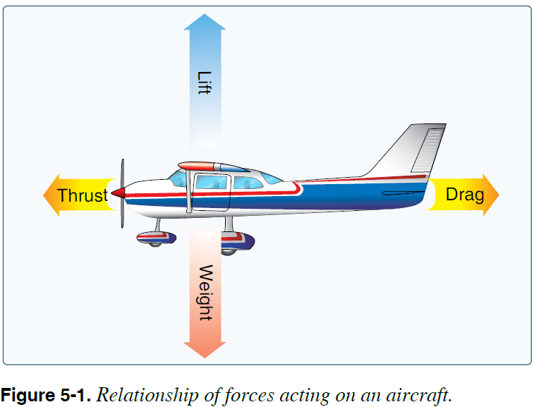
- Principles of Flight - Principle of Differential Pressure
- Daniel Bernoulli – Swiss Mathematician 1730
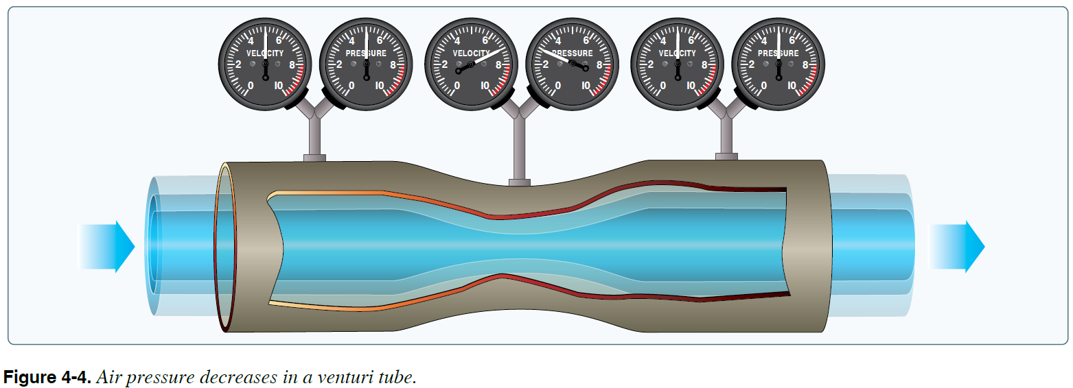

Typical Airfoil
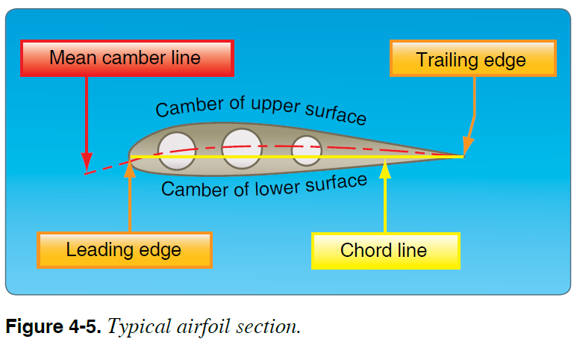

Relative Wind
Angle of attach (AOA)
Higher pressure below, lower pressure above
All lift is said to act at the Center of Pressure (CP)
Higher AOA creates larger differential pressure – more lift
Higher speed creates larger diff pressure – more lift
Penalty of creating lift is drag – Induced Drag
Penalty of moving wing and airplane thru the air is drag – Parsite Drag
Product of creating lift is drag – Creation of Wing Tip Vortices around wing tip
Wake Turbulence Generation
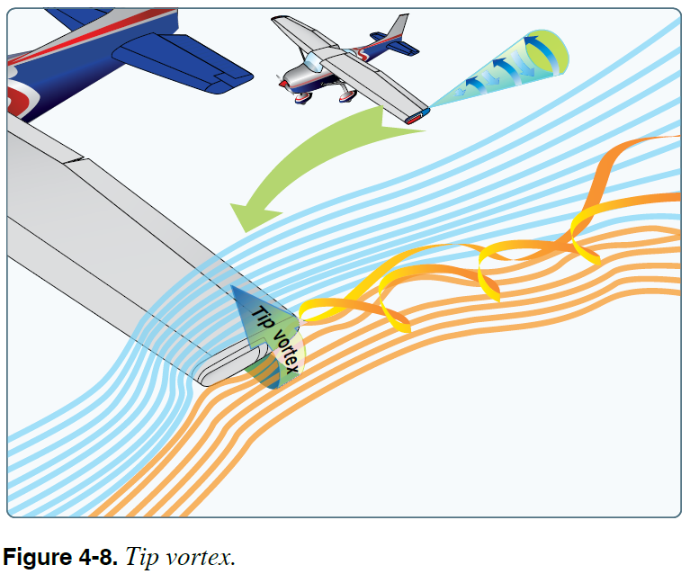

Drag PHOAK 5-6
  - Parasite Drag PHOAK 5-6
    - Form PHOAK 5-6
    - Interference PHOAK 5-6
    - Skin Friction PHOAK 5-6

  - Induced Drag PHOAK 5-7

- Axis of an Airplane
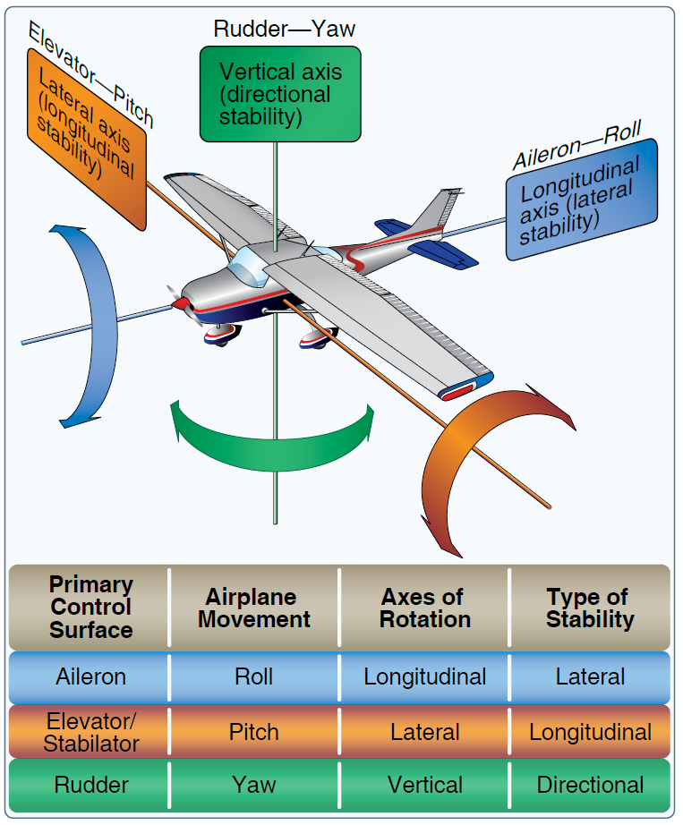
- Flight Controls
Primary: Ailerons, Elevators, Rudder
Secondary: Flaps, Trim

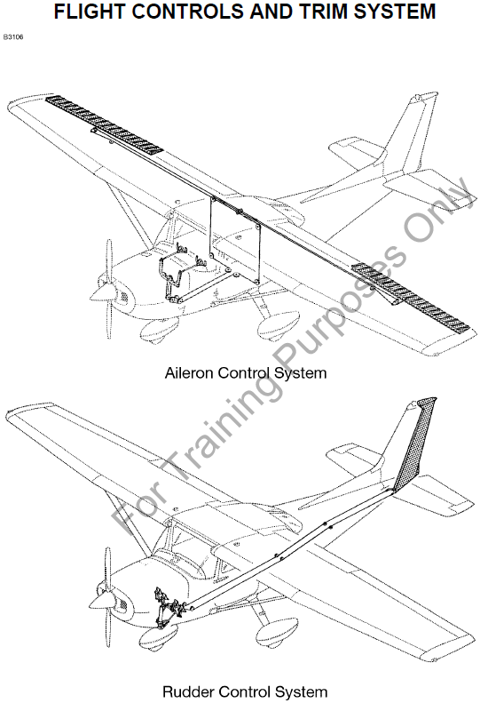

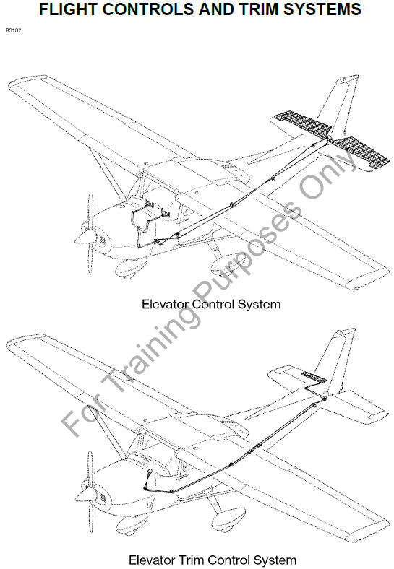

- Back to 4 Forces
Four forces are equal in unaccelerated flight
Level, climbing, descending

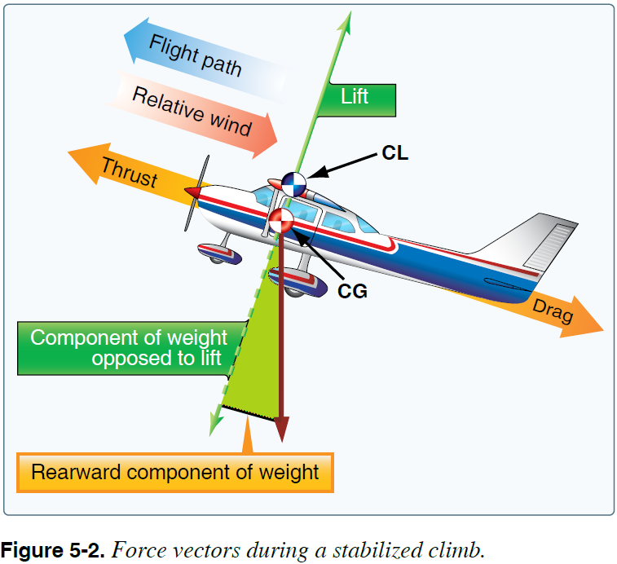

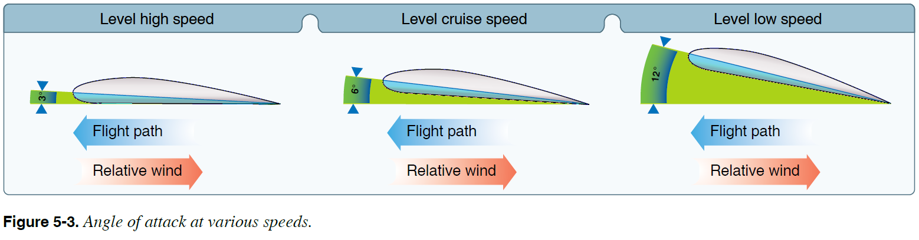

Pilot controls amount of lift in two ways.
AOA lift is proportional to AOA
Airspeed lift varies with square of the airspeed
Only so much AOA – critical angle of attack – STALL
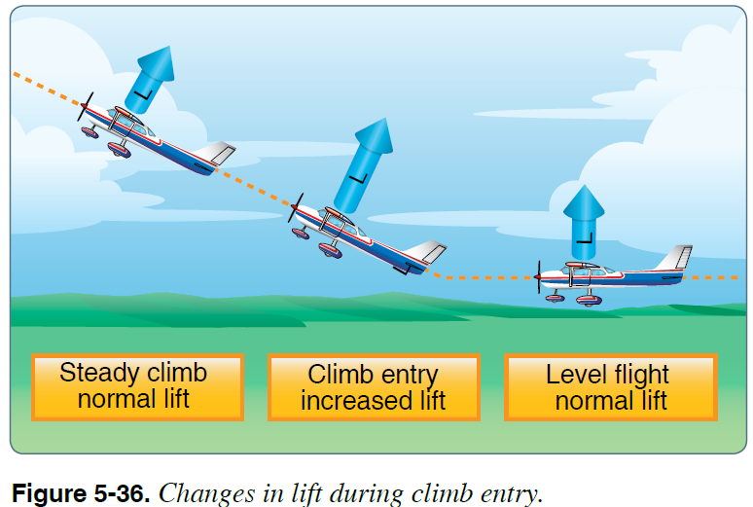

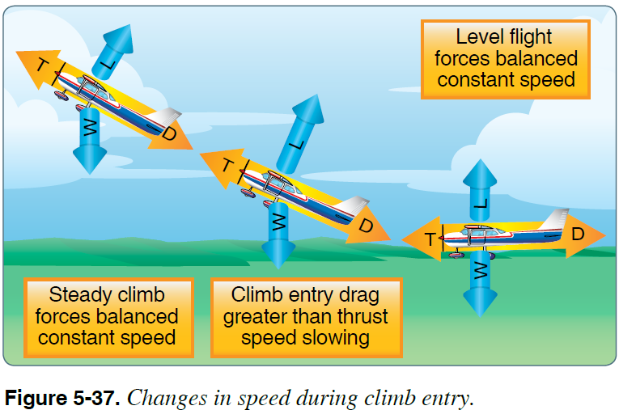

- What makes an airplane turn
- Horizontal component of lift

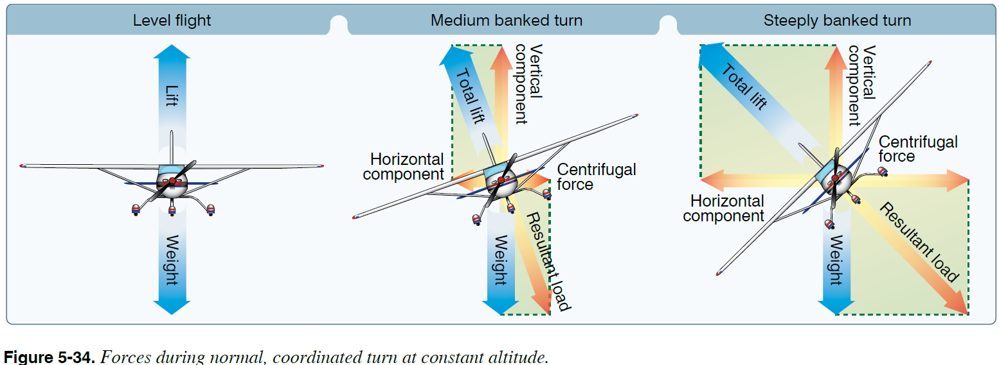

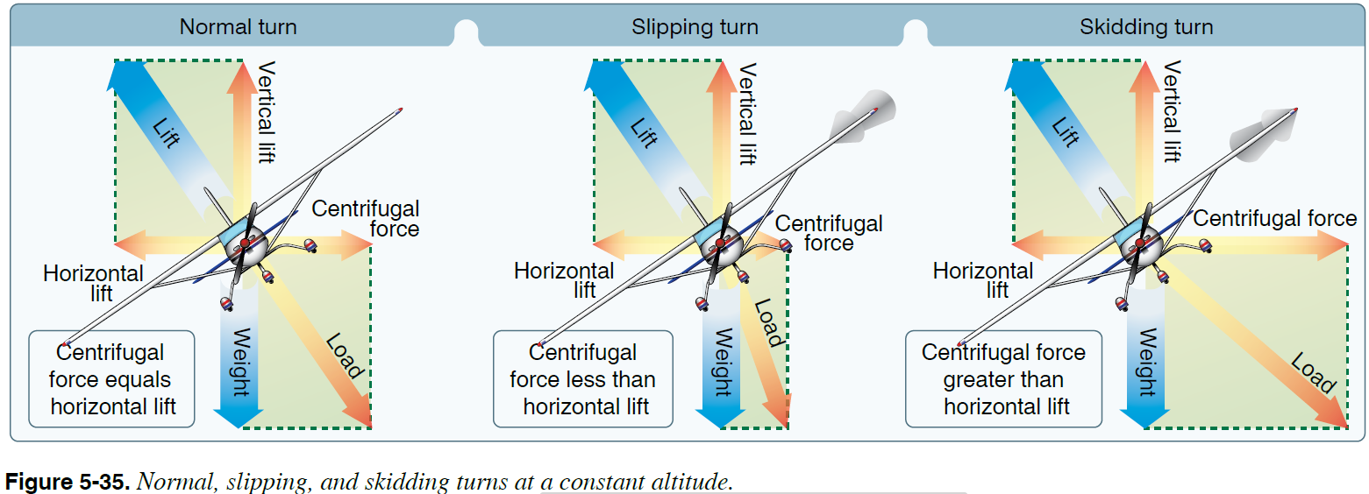
- Adverse Yaw

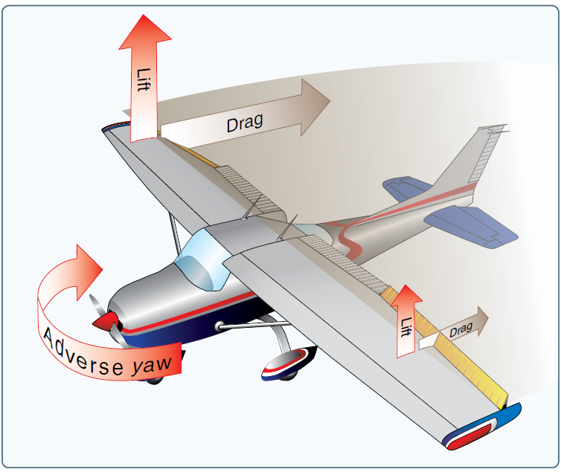
- Load Factor

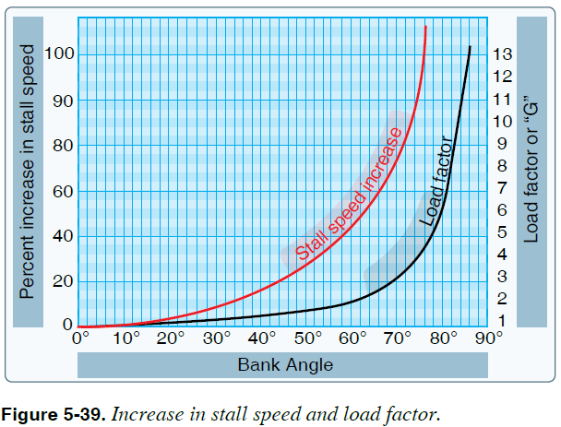

@45º LF=1.4
20% increase in stall speed
48 kts > 57 kts
42 kts > 50 kts

@50º LF=1.5
27% increase in stall speed
48 kts > 61 kts
42 kts > 54 kts

@60º LF=2.0
42% increase in stall speed
48 kts > 68 kts
42 kts > 60 kts

- Back to AOA

Higher AOA = higher diff press, therefore higher lift
Critical angle of attack (AOA) - WING STALLS

Two ways to create more lift:
Increase AOA
Increase Airspeed
AOA doubles - lift doubles
Airspeed doubles - lift quaduples

Penalty of lift is induced drag

Parasite drag vs Induced Drag

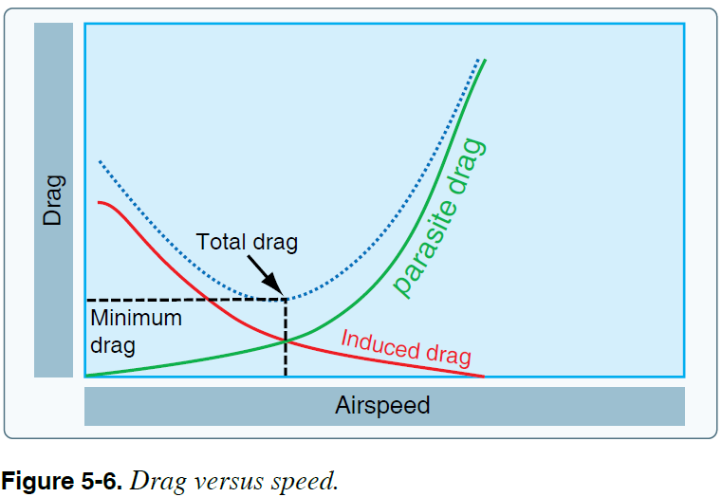
- Wingtip Vortices
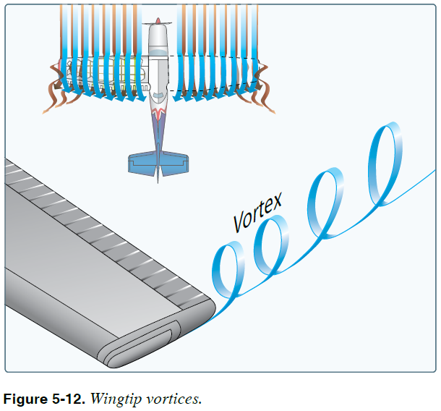
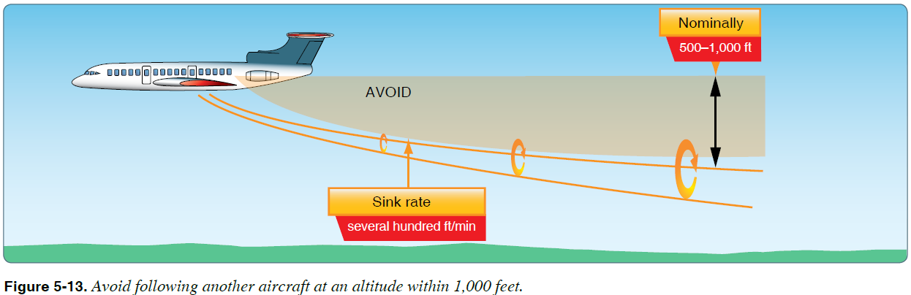

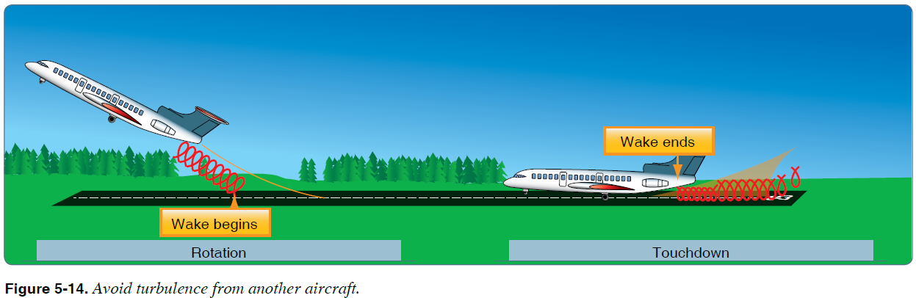
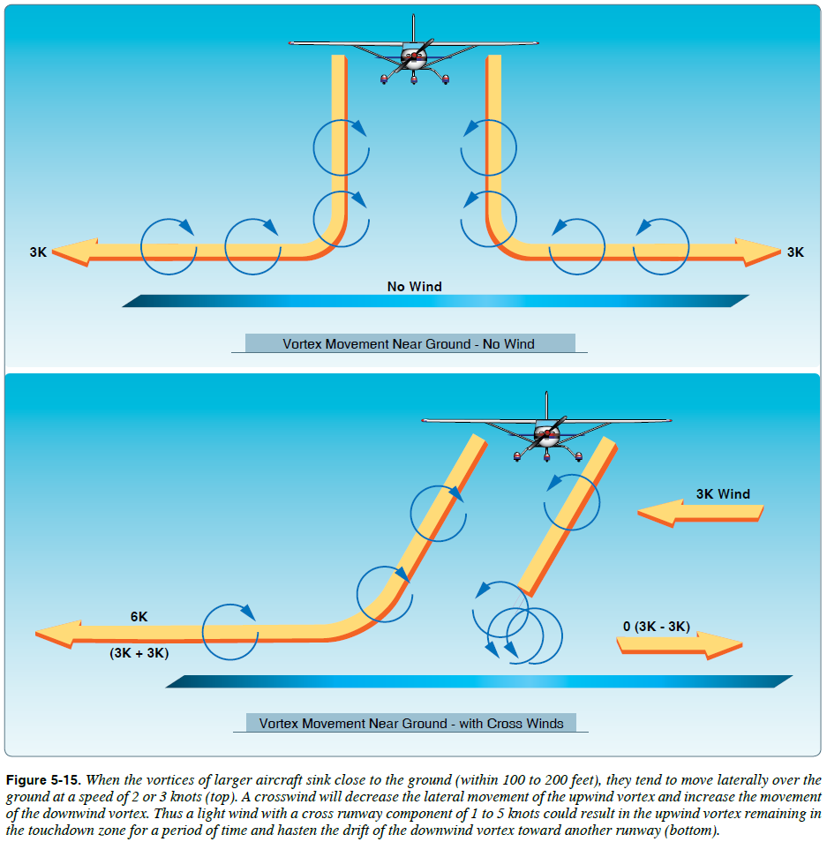
- Ground Effect
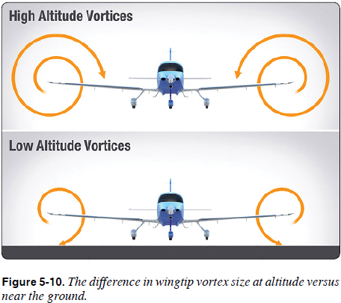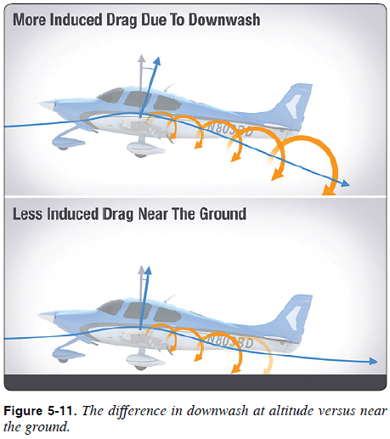

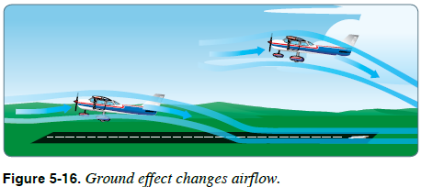
- Left Turning Tendency
Caused by: 1) Torque reaction from engine and propeller
2) Corkscrewing effect of the slipstream
3) Gyroscopic action of the propeller
4) Asymmetric loading of the propeller (P Factor)
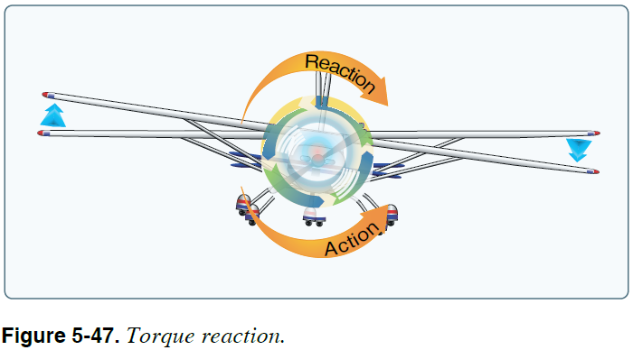
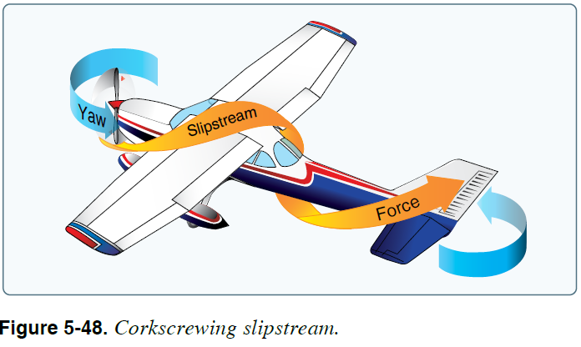
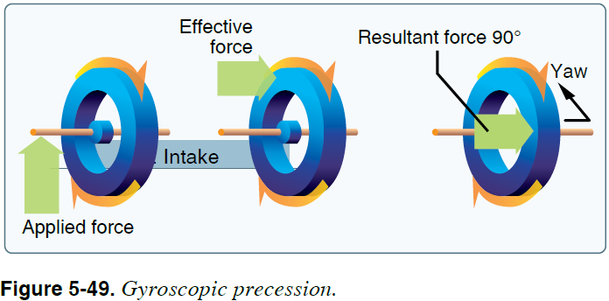
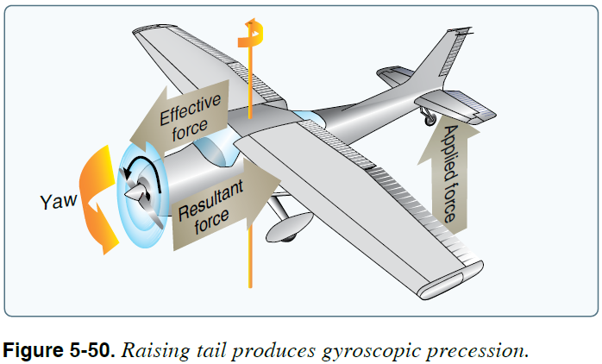
Left Turning Tendency (con’t)

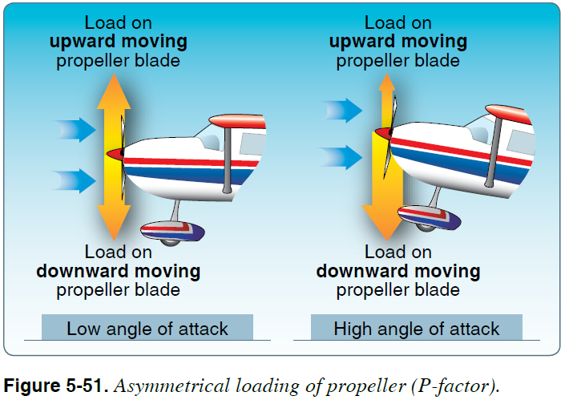

- Stability
Static - positive, neutral, negative
Dynamic – positive, neutral, negative
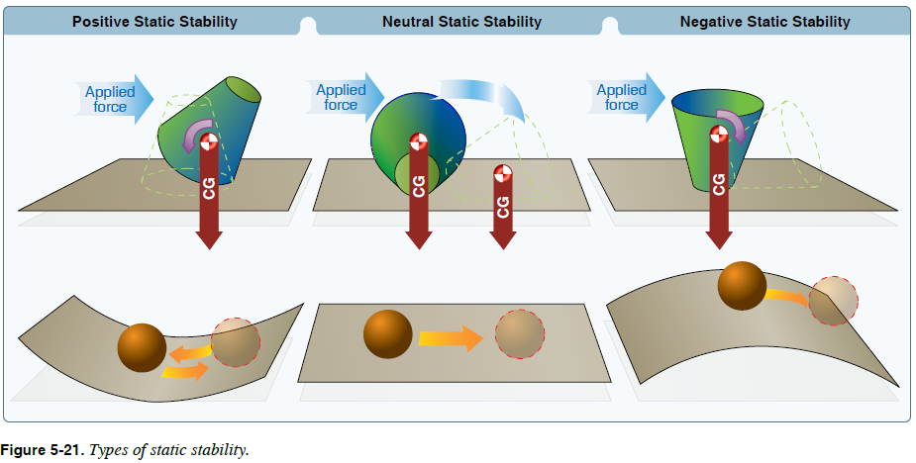

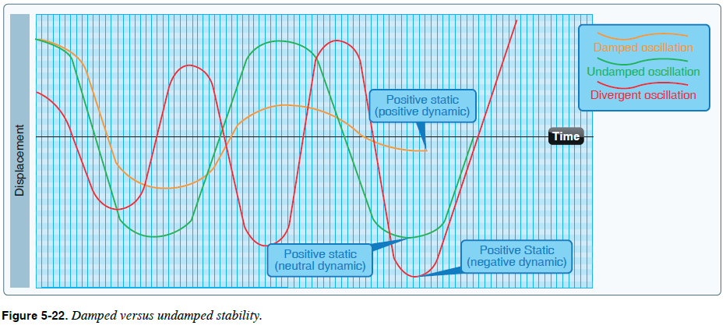

- Lateral & Longitudinal Stability – W & B
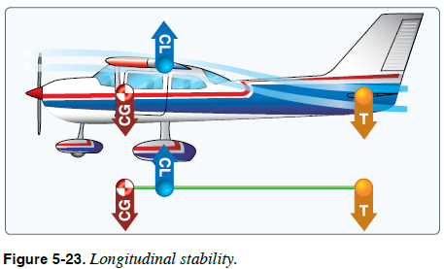

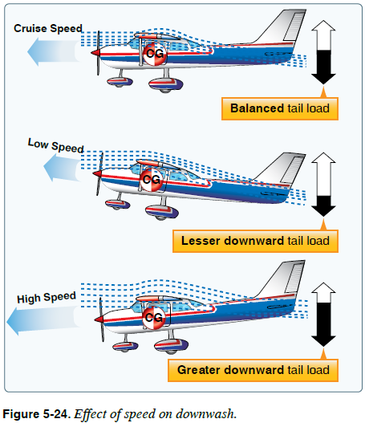

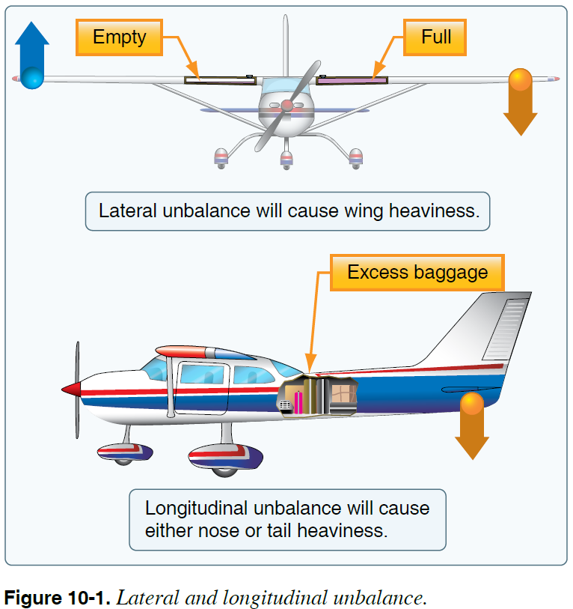

- Weight & Balance – Longitudinal Stability

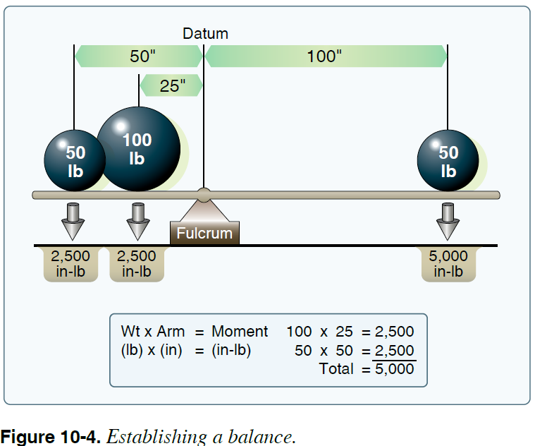

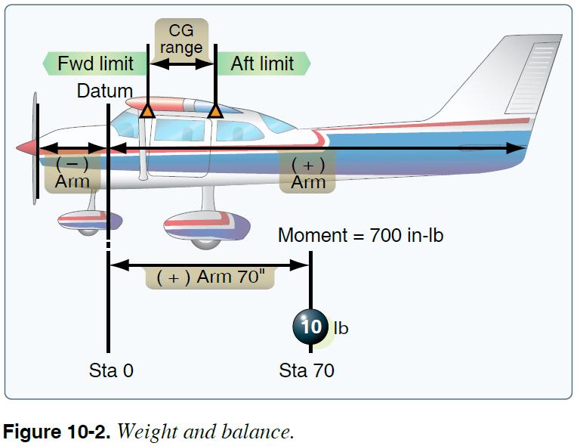

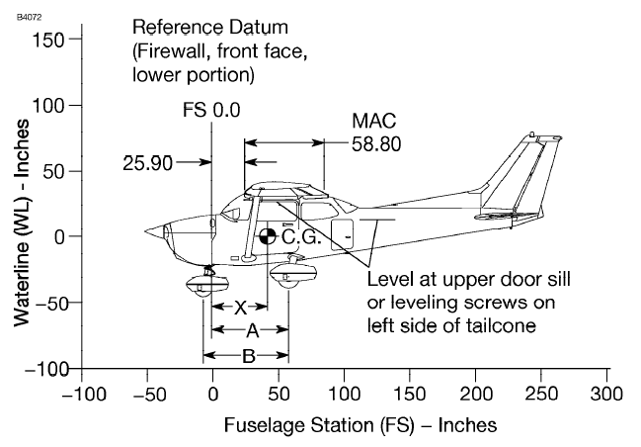

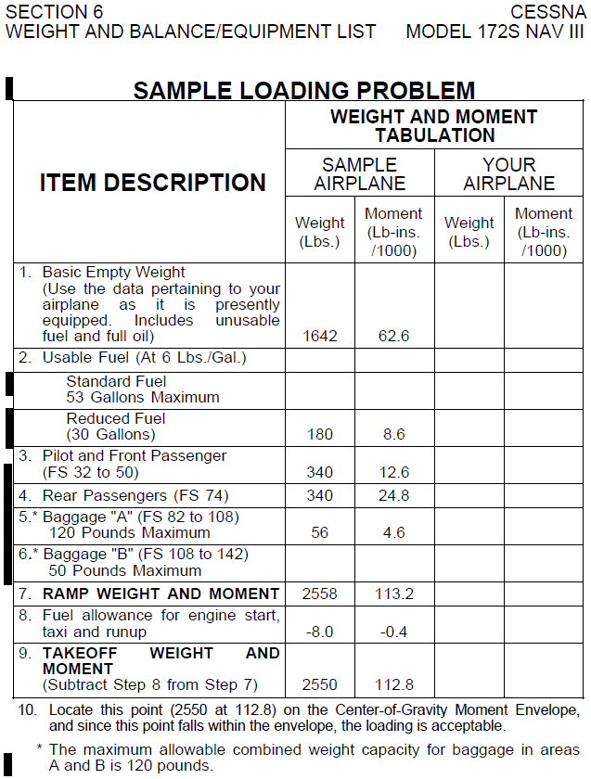
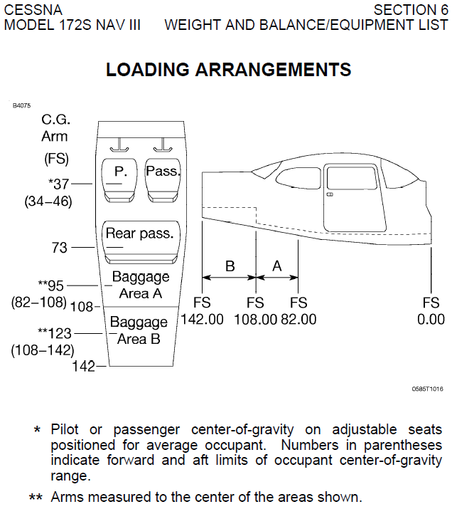

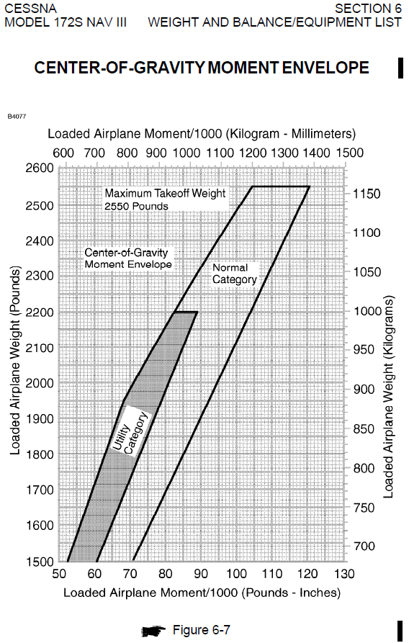
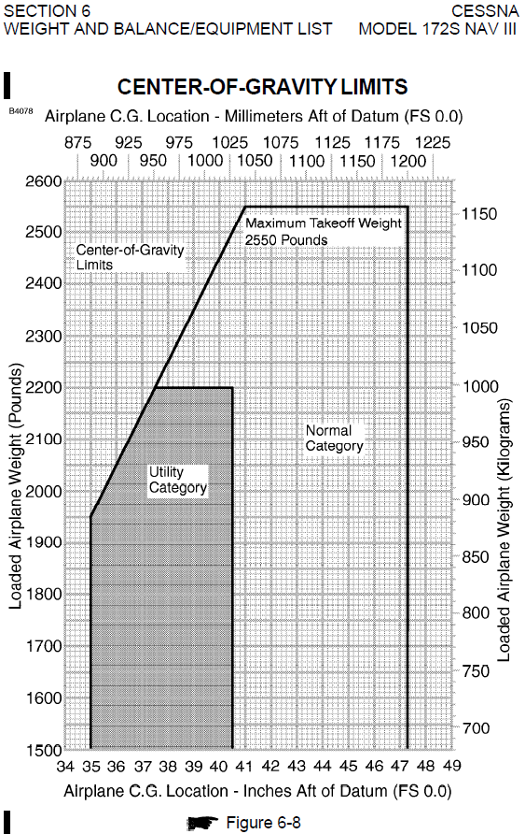
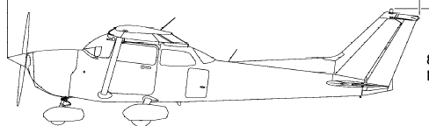
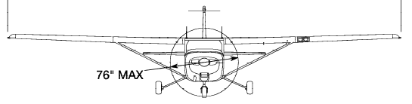
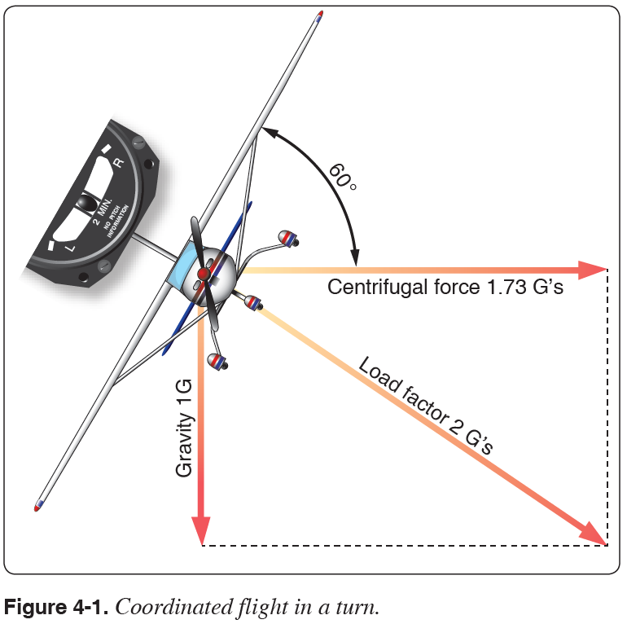

Maneuvering Speed (Va)
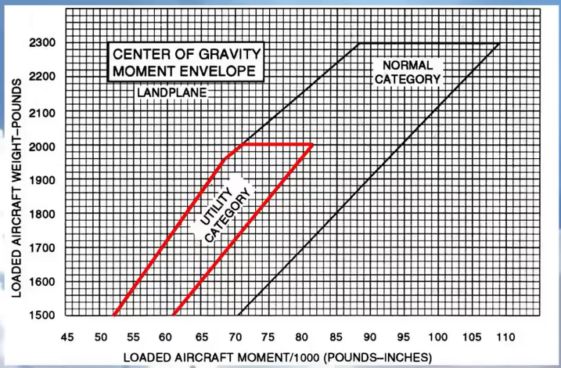

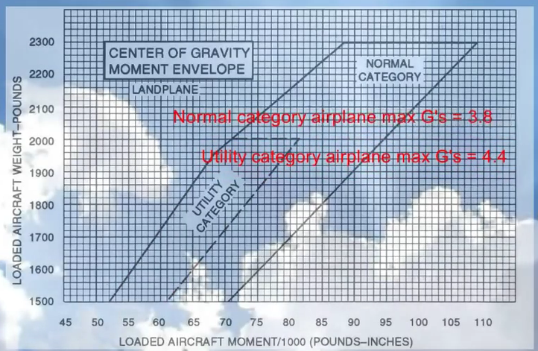

Maneuvering Speed (Va)
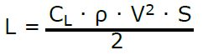

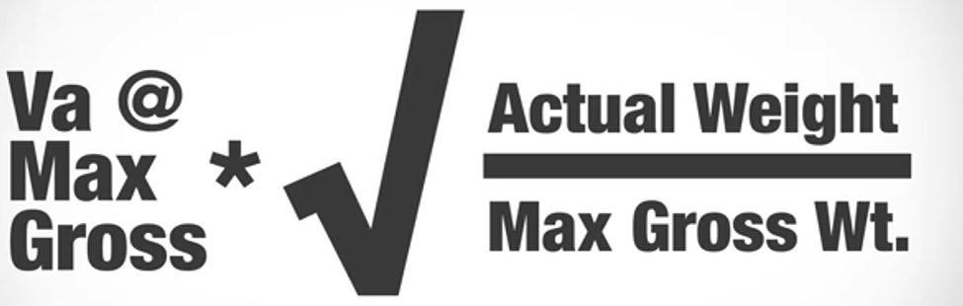

Maneuvering Speed (Va)
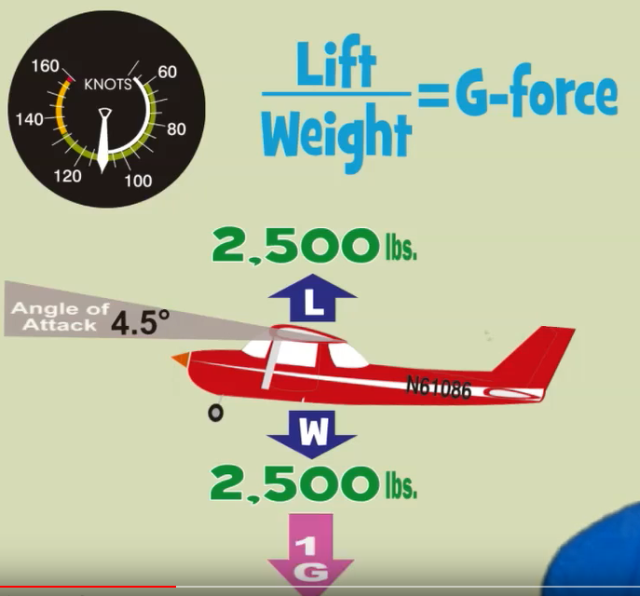
Airplane flying at 110 kts, gross weight = 2,500 #’s, AOA = 4.5º

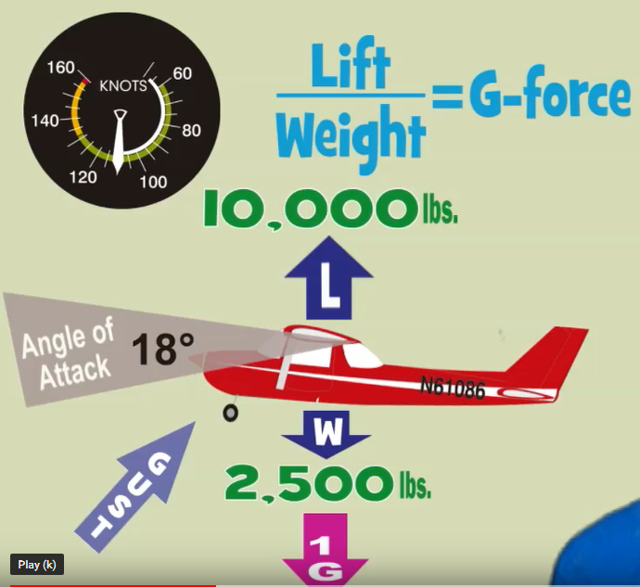
If critical AOA is 18º, at 110 kts airplane will only experience 4 G’s before reaching critical AOA
Maneuvering Speed (Va)
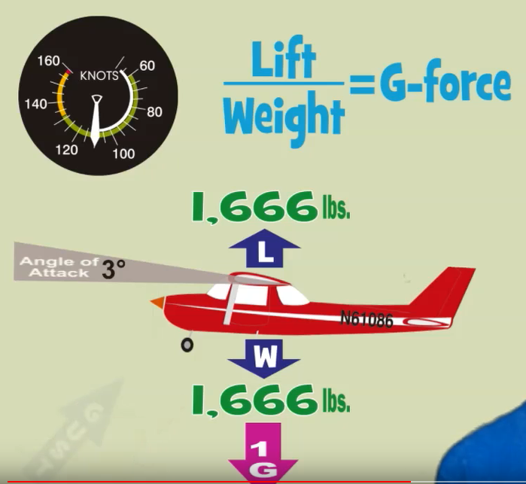
Same airplane flying at 110 kts, gross weight = 1,666 #’s, AOA = 3.0º

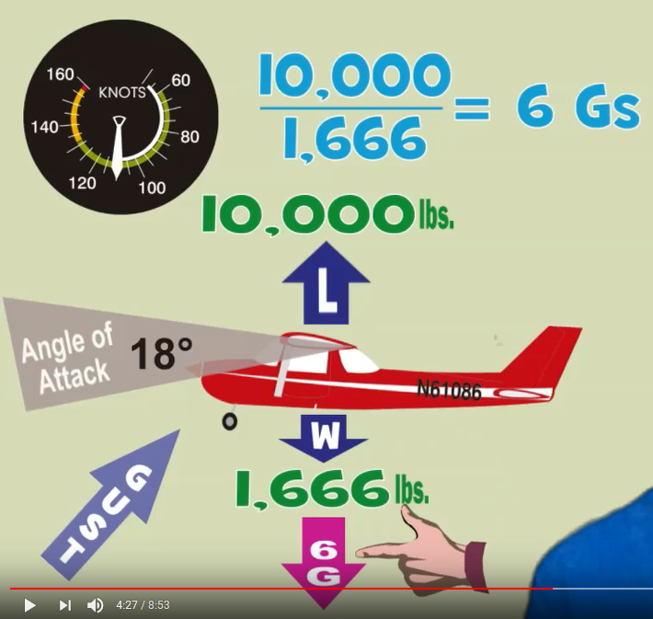
Critical AOA is still 18º, at 110 kts the airplane can now experience 6 G’s
before reaching critical AOA, which would exceed the max design load.

Maneuvering Speed (Va)
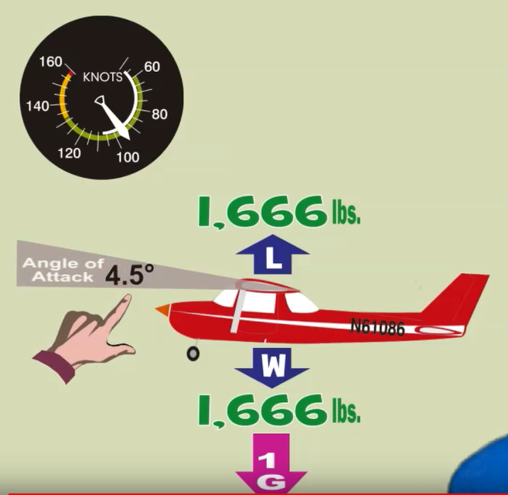
Same airplane flying at 95 kts, gross weight = 1,666 #’s, AOA is now = 4.5º

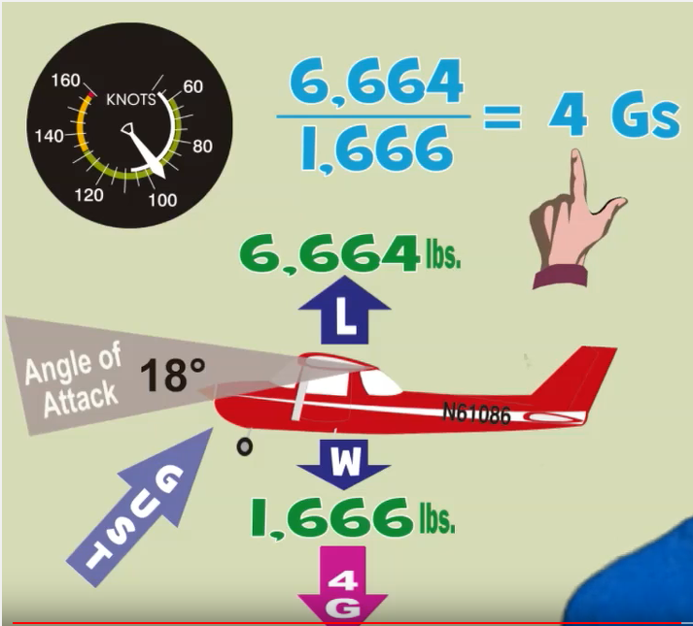
At this lighter gross weight, if critical AOA is 18º, at 95 kts airplane will only
experience 4 G’s before reaching critical AOA.

